**UPLOAD A STATIC WEBSITE ON S3**

**Keep the html files ready.Visit** **aws.amazon.com** **and Sign in.Click on the search field and type “S3” in the search field and select “S3”**

**Click on “Buckets”**

**1.….**.

**2.**

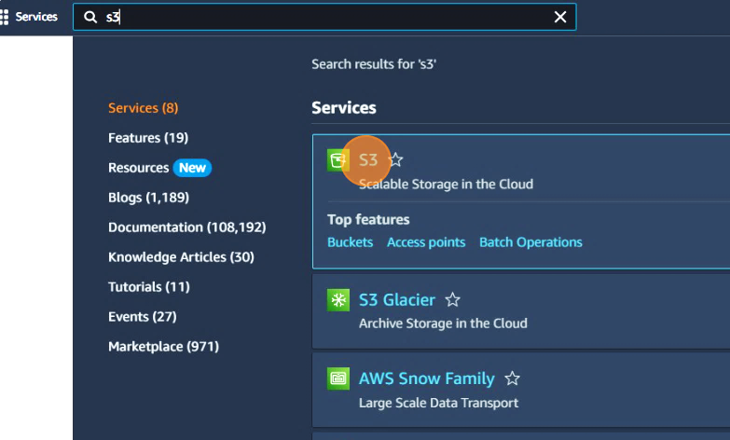

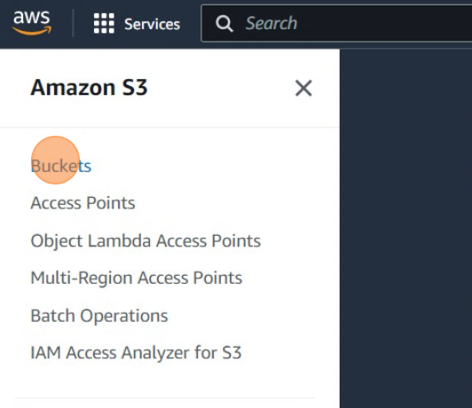

**Create a public bucket and click on it**

**Click on upload button**

**s**

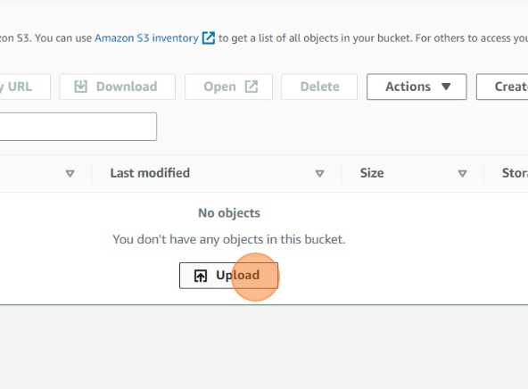

**3.**

**4.….**.

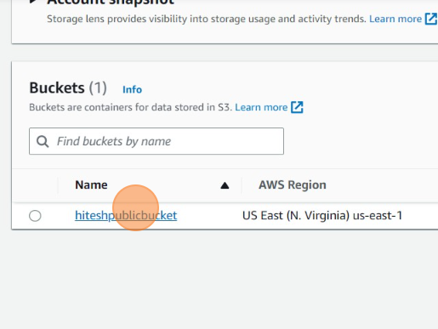

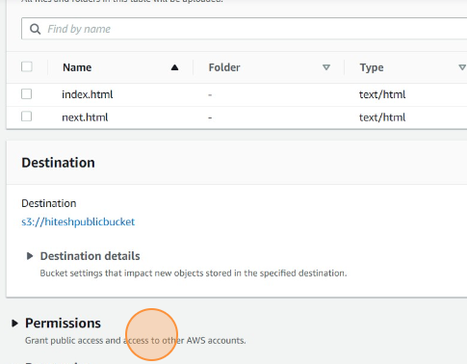

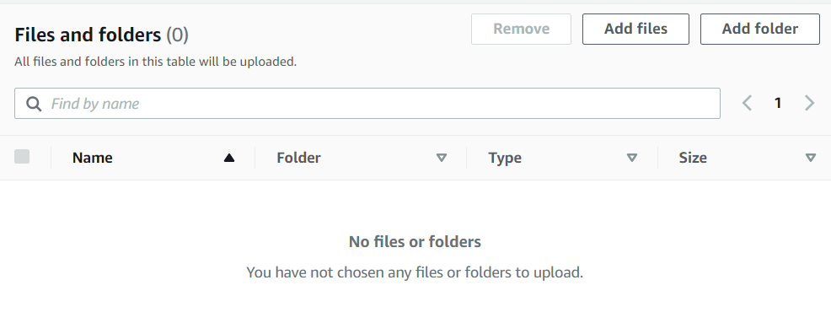

**Select the html files you want to upload by clicking on “Add files”**

**Click on “Permissions”**

**5.….**.

**6.**

**Go to public bucket in which the website was uploaded.Select the properties tab**

**Select the option “Choose from predefined ACLs”,”Grant public-read access”,check the checkbox “I understand the risk of …..” and then upload the file**

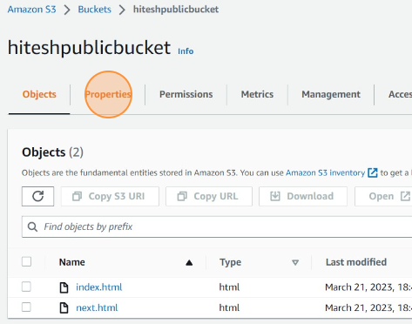

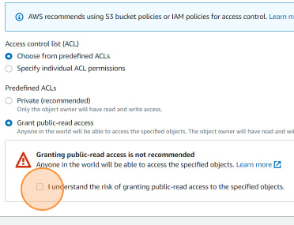

**7.….**.

**8.**

**Choose the option “Enable” for static website hosting,then choose “Host a static website” and specify the index document of the website.Finally click on save changes**

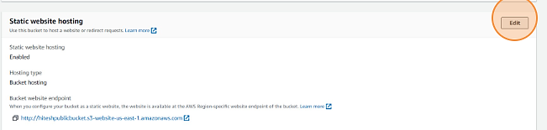

**S**

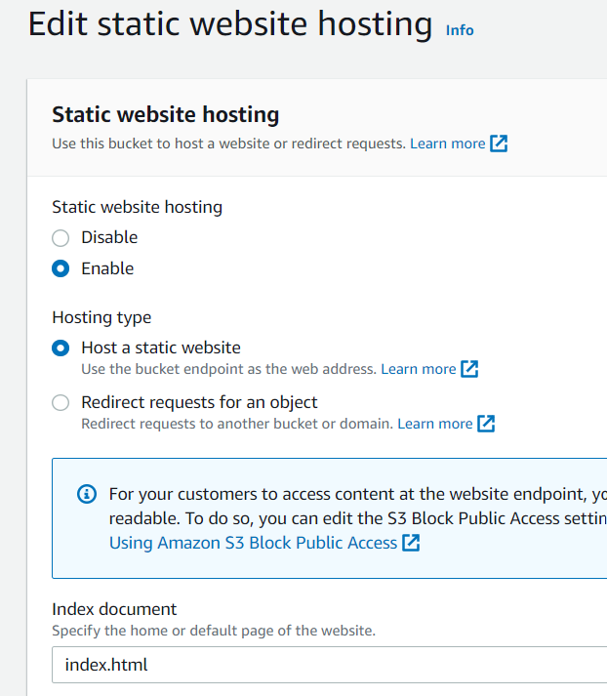

**Go to static website section and click on “Edit”**

**10.**

**9.**

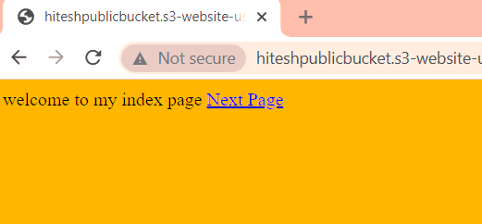

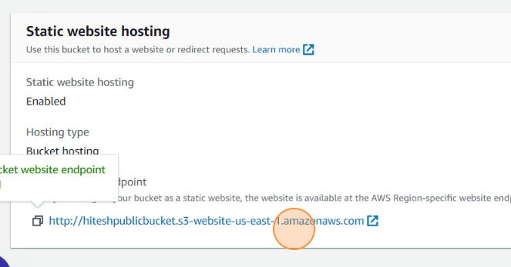

**The website is accessible**

**12.**

**After saving changes go down and find the bucket website endpoint link.See whether the website is accessible or not across different devices**

**11.**